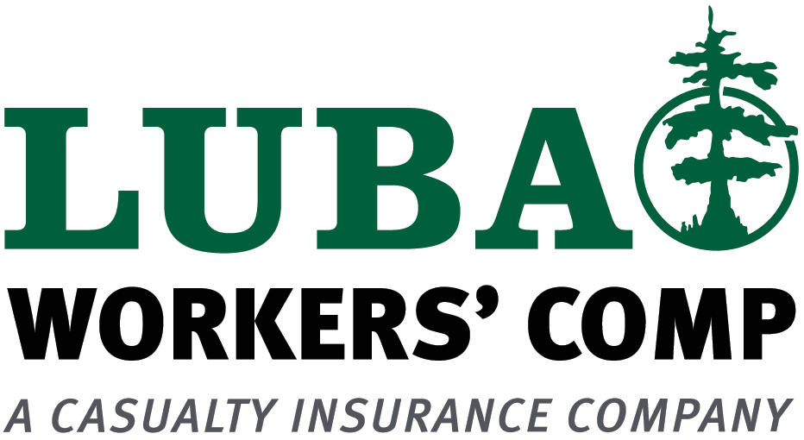

LUBA Workers' Comp
Nursing/Convalescent Home/Retirement Living Facility Questionnaire

NAME: ________________________________________________ QUOTE #:________
AGENCY__________________________________________________

Retirement Living Centers are distinguished from Nursing Homes by the fact that these operations are similar to rental or condominium-type housing complexes with apartment type environment. Medical assistance, meals and other personal assistance is available, but not on a 24 hour basis.

Nursing Homes provide 24 hour nursing care to individual building unit occupants with setup more like a hospital or dormitory.

Retirement Living Facility | Code 8829-Convalescent or Nursing Home
Code 8824- Health Care Employees  Code 8825-Food Service Employees  Code 8826- Drivers/Maintenance/Housekeeping/Outside Sales  Payroll Breakdown and # of employees is included on Acord WC application?_______ | #of Skilled Beds: ______# of Intermediate Beds:_____  # of Assisted Living Beds:___# of owned vehicles_____  Code 8829 does not include drivers, clerical or outside sales:  Codes 7380, 8810 & 8742 would apply  Payroll Breakdown and # of employees to be shown on Acord WC application
Location #______Address:_______________________________________________________________________
(Provide additional locations and separate entity names (if applicable) on following page)

- Are any employees paid by 1099? If so, what are their duties?_____________________________________
Is payroll included?

- Are employees tested for communicable diseases prior to hiring and periodically thereafter? Yes No
- Describe hiring practices:____________________________________________________________________________

- Is there a safety program in place? If so, give details.______________________________________________________

- # of vehicles owned and used to transport patients? # of drivers? Is driver payroll included in Code 7380 on application? If not, provide separate payroll for drivers to be added under Code 7380

- Are MVR’s checked and updated annually for all drivers? _________________________________________________

- Are periodic health exams performed? Yes No
- Do workers give injections? If yes, describe ____________________________________________________________

- Describe procedures in place for disposing needles and medical waste: _______________________________________
________________________________________________________________________________________________

- Do any employees handle hazardous materials (i.e. chemo therapy drugs)_____________________________________

- Describe patient lifting procedures in place:_____________________________________________________________

- Are the workers exposed to AIDS? HIV? Blood/body fluids, pathogens, etc. If yes, describe. _____________________
________________________________________________________________________________________________

- Are workers provided with uniforms, meals, mileage, etc., (i.e. remuneration of any kind)? _______________________
________________________________________________________________________________________________

- What training is required for new employees?____________________________________________________________

________________________________________________________________________________________________
ADDITIONAL LOCATIONS: List on next page

Separate Entity Name (if applicable)
Location #____Address

Retirement Living Facility | Code 8829-Convalescent or Nursing Home
Code 8824- Health Care Employees  Code 8825-Food Service Employees  Code 8826- Drivers/Maintenance/Housekeeping/Outside Sales  Payroll Breakdown and # of employees is included on Acord WC application?_______ | #of Skilled Beds: ______# of Intermediate Beds:_____  # of Assisted Living Beds:___# of owned vehicles_____  Code 8829 does not include drivers, clerical or outside sales:  Codes 7380, 8810 & 8742 would apply  Payroll Breakdown and # of employees to be shown on Acord WC application

Separate Entity Name (if applicable)
Location #____Address

Retirement Living Facility | Code 8829-Convalescent or Nursing Home
Code 8824- Health Care Employees  Code 8825-Food Service Employees  Code 8826- Drivers/Maintenance/Housekeeping/Outside Sales  Payroll Breakdown and # of employees is included on Acord WC application?_______ | #of Skilled Beds: ______# of Intermediate Beds:_____  # of Assisted Living Beds:___# of owned vehicles_____  Code 8829 does not include drivers, clerical or outside sales:  Codes 7380, 8810 & 8742 would apply  Payroll Breakdown and # of employees to be shown on Acord WC application
Separate Entity Name (if applicable)
Location #____Address

Retirement Living Facility | Code 8829-Convalescent or Nursing Home
Code 8824- Health Care Employees  Code 8825-Food Service Employees  Code 8826- Drivers/Maintenance/Housekeeping/Outside Sales  Payroll Breakdown and # of employees is included on Acord WC application?_______ | #of Skilled Beds: ______# of Intermediate Beds:_____  # of Assisted Living Beds:___# of owned vehicles_____  Code 8829 does not include drivers, clerical or outside sales:  Codes 7380, 8810 & 8742 would apply  Payroll Breakdown and # of employees to be shown on Acord WC application
Separate Entity Name (if applicable)
Location #____Address

Retirement Living Facility | Code 8829-Convalescent or Nursing Home
Code 8824- Health Care Employees  Code 8825-Food Service Employees  Code 8826- Drivers/Maintenance/Housekeeping/Outside Sales  Payroll Breakdown and # of employees is included on Acord WC application?_______ | #of Skilled Beds: ______# of Intermediate Beds:_____  # of Assisted Living Beds:___# of owned vehicles_____  Code 8829 does not include drivers, clerical or outside sales:  Codes 7380, 8810 & 8742 would apply  Payroll Breakdown and # of employees to be shown on Acord WC application

Duplicate this page if there are additional locations or entities that need to be included

